Dear Family,

Thanks to a new program funded by the City of Muncie and U.S. Department of Housing and Urban Development, you may be able to get some help with lead removal for your home. As a community, we understand that lead exposure is a serious issue and want to provide this service to help families thrive.

Receiving this letter does NOT mean you will automatically be accepted into the lead removal program. Many different things factor into who will be accepted. Factors include home ownership status, the age of your children, and the cost of removing lead from your home.

To apply for the program:
- Fill out the application form in this packet. Make sure your contact information is
up-to-date.
- Drop off or mail these forms to:

Habitat for Humanity
1923 S. Hoyt Avenue
Muncie, IN 47302
If you are selected, we will be in touch with you through the contact information listed on your application form. Thank you for your time. If you have any questions, feel free to contact us at 765-216-7423.

Sincerely,

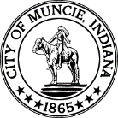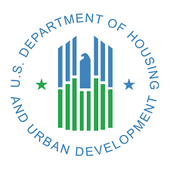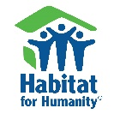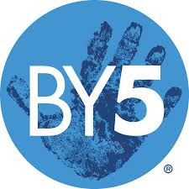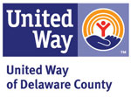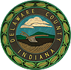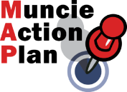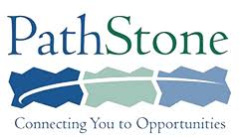

City of Muncie/HUD Lead Removal Program
Application Form

Name: Date of birth:
Street address:
City: State: ZIP:

Phone number:
Back-up phone number: (optional)
Email address:

Names of all people who live in your house:

Name Age Relation to you

(If you have more family members than will fit here, please list their info on the back of this sheet)

Age of the Home (Year of construction) ______________

Do you own your home?
- Yes
- No

Please put a checkmark once you have completed the following items:
- I have completed all items on this application sheet.

Signing below indicates that you understand this application is not a guarantee that you will be accepted into the lead removal program. It also indicates that all the information you have provided in this packet is true.

_______________________________________________ _____________
Signature Date

Please drop off or mail this form to:
Habitat for Humanity
1923 S. Hoyt Ave.
Muncie, IN 47302

